1.Prepare accounting equation on the basis of the following:
(a) Harsha started business with cash Rs 2,00,000
(b) Purchased goods from Naman for cash Rs 40,000
(c) Sold goods to Bhanu costing Rs 10,000/- Rs 12,000
(d) Bought furniture on credit Rs 7,000
2. 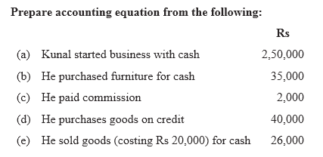
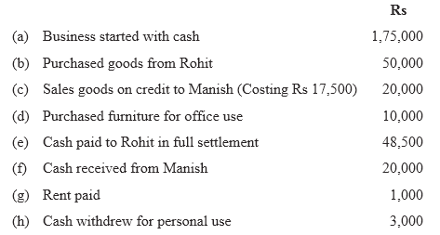

. Q3. Mohit has the following transactions, prepare accounting equation:

Q4. Rohit has the following transactions:

Test Your Understanding - I 1. Double entry accounting requires that : (i) All transactions that create debits to asset accounts must create credits to liability or capital accounts; (ii) A transaction that requires a debit to a liability account require a credit to an asset account; (iii) Every transaction must be recorded with equal debits equal total credits. 2. State different kinds of transactions that increase and decrease capital. 3. Does debit always mean increase and credit always mean decrease? 4. Which of the following answers properly classifies these commonly used accounts: (1) Building (2) Wages (3) Credit sales (4) Credit purchases (5) Electricity charges due but not yet paid(outstanding electricity bills) (6) Godown rent paid in advance(prepaid godown rent) (7) Sales (8) Fresh capital introduced (9) Drawings (10) Discount paid Assets Liabilities Capital Revenue Expense (i) 5,4, 3, 9,6 2,10 8,7 (ii) 1, 6 4, 5 8 7, 3 2,9,10 (iii) 2,10,4 4,6 8 7,5 1,3,9
Test Your Understanding - III Choose the Correct Answer : 1. The ledger folio column of journal is used to: (a) Record the date on which amount posted to a ledger account. (b) Record the number of ledger account to which information is posted. (c) Record the number of amounts posted to the ledger account. (d) Record the page number of the ledger account. 2. The journal entry to record the sale of services on credit should include: (a) Debit to debtors and credit to capital. (b) Debit to cash and Credit to debtors. (c) Debit to fees income and Credit to debtors. (d) Debit to debtors and Credit to fees income. 3. The journal entry to record purchase of equipment for Rs. 2,00,000 cash and a balance of Rs. 8,00,000 due in 30 days include: (a) Debit equipment for Rs. 2,00,000 and Credit cash 2,00,000. 66 Accountancy (b) Debit equipment for Rs. 10,00,000 and Credit cash Rs. 2,00,000 and creditors Rs. 8,00,000. (c) Debit equipment Rs. 2,00,000 and Credit debtors Rs. 8,00,000. (d) Debit equipment Rs. 10,00,000 and Credit cash Rs. 10,00,000. 4. When a entry is made in journal: (a) Assets are listed first. (b) Accounts to be debited listed first. (c) Accounts to be credited listed first. (d) Accounts may be listed in any order. 5. If a transaction is properly analysed and recorded: (a) Only two accounts will be used to record the transaction. (b) One account will be used to record transaction. (c) One account balance will increase and another will decrease. (d) Total amount debited will equals total amount credited. 6. The journal entry to record payment of monthly bill will include: (a) Debit monthly bill and Credit capital. (b) Debit capital and Credit cash. (c) Debit monthly bill and Credit cash. (d) Debit monthly bill and Credit creditors. 7. Journal entry to record salaries will include: (a) Debit salaries Credit cash. (b) Debit capital Credit cash. (c) Debit cash Credit salary. (d) Debit salary Credit creditors.
5. Use accounting equation to show the effect of the following transactions of M/s Royal Traders:
(a) Started business with cash Rs.1,20,000
(b) Purchased goods for cash Rs. 10,000
(c) Rent received Rs. 5,000
(d) Salary outstanding Rs. 2,000
(e) Prepaid Insurance Rs. 1,000
f) Received interest Rs. 700
(g) Sold goods for cash (Costing Rs. 5,000) Rs. 7,000
(h) Goods destroyed by fire Rs. 500
(Ans: Assets = Cash Rs. 1,22,700 + Goods Rs. 4,500 + Prepaid insurance Rs. 1,000; Liabilities = Outstanding salary Rs. 2,000 + Capital Rs. 1,26,200)
6. Show the accounting Equation on the basis of the following transaction: (a) Udit started business with:
(i) Cash Rs. 5,00,000
(ii) Goods Rs. 1,00,000
(b) Purchased building for cash Rs. 2, 00,000
(c) Purchased goods from Himani Rs. 50,000
(d) Sold goods to Ashu (Cost Rs. 25,000) Rs. 36, 000
(e) Paid insurance premium Rs. 3,000
(f) Rent outstanding Rs. 5,000
(g) Depreciation on building Rs. 8,000
(h) Cash withdrawn for personal use Rs. 20,000
(i) Rent received in advance Rs. 5,000
(j) Cash paid to himani on account Rs. 20,000
(k) Cash received from Ashu Rs. 30,000
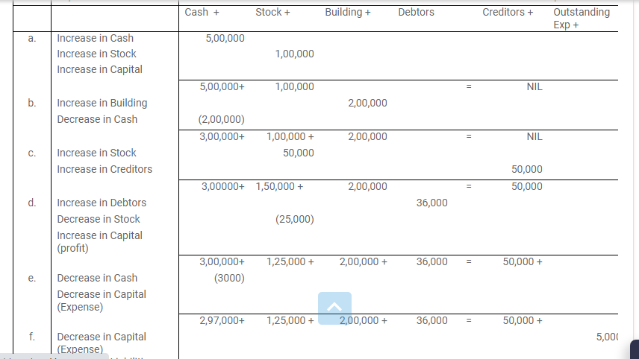
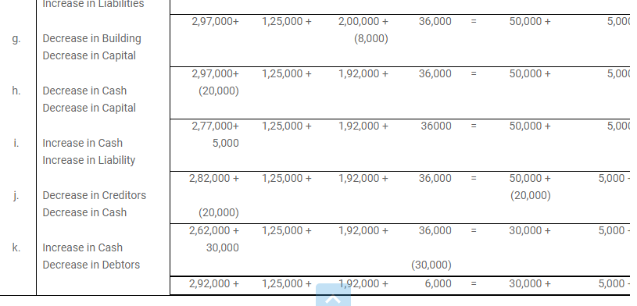
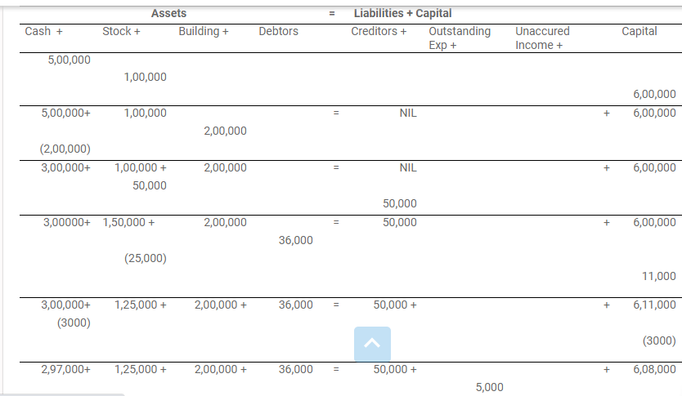
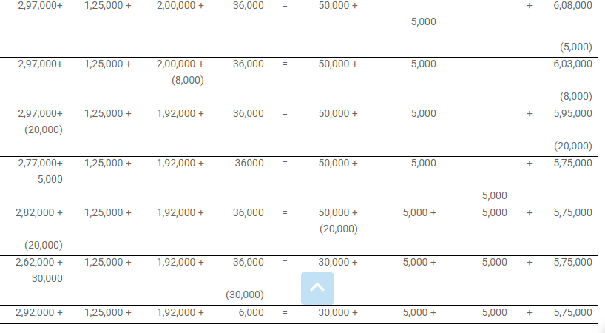

(Ans : Assets = Cash Rs. 2,92,000 + Goods Rs. 1,25,000 + Building Rs. 1,92,000 + Debitors Rs. 6,000 = 6,15,000: Laibilities = Creditors Rs. 30,000 + Outstanding Rent Rs. 5,000 + Rent Rs. 5,000 + Capital Rs. 5,75,000 = Rs. 6,15,000)
7. Show the effect of the following transactions on Assets, Liabilities and Capital through accounting equation:
(a) Started business with cash Rs. 1,20,000
(b) Rent received Rs. 10,000
(c) Invested in shares Rs. 50,000
(d) Received dividend Rs. 5,000
(e) Purchase goods on credit from Ragani Rs. 35,000
(f) Paid cash for house hold Expenses Rs. 7,000
(g) Sold goods for cash (costing Rs.10,000) Rs. 14,000
(h) Cash paid to Ragani Rs. 35,000
(i) Deposited into bank Rs. 20,000
(Ans: Assets = Cash Rs. 37,000 + Shares Rs. 50,000 + Goods Rs. 25,000 + Bank Rs. 20,000 = Rs. 1,32,000; Liabilities = Capital Rs. 1,32,000)
8. Show the effect of following transaction on the accounting equation: (a) Manoj started business with (i) Cash Rs. 2,30,000 Recording of Transactions - I 83 (ii) Goods Rs. 1,00,000 (iii) Building Rs. 2,00,000 (b) He purchased goods for cash Rs. 50,000 (c) He sold goods(costing Rs.20,000) Rs. 35,000 (d) He purchased goods from Rahul Rs. 55,000 (e) He sold goods to Varun (Costing Rs. 52,000) Rs. 60,000 (f) He paid cash to Rahul in full settlement Rs. 53,000 (g) Salary paid by him Rs. 20,000 (h) Received cash from Varun in full settlement Rs. 59,000 (i) Rent outstanding Rs. 3,000 (j) Prepaid Insurance Rs. 2,000 (k) Commission received by him Rs. 13, 000 (l) Amount withdrawn by him for personal use Rs. 20,000 (m) Depreciation charge on building Rs. 10,000 (n) Fresh capital invested Rs. 50,000 (o) Purchased goods from Rakhi Rs. 6,000 (Ans: Assets = Cash Rs. 2,42,000 + Goods Rs. 1,43,000 +Building Rs.1,90,000 + Prepaid Insurouce Rs. 2,000 = Rs. 5,77,000; Liabilities = Outstanding Rent Rs. 3,000 + Creditor Rs. 10,000 + Capital Rs. 5,64,000 = Rs. 5,77,000) 9. Transactions of M/s Vipin Traders are given below. Show the effects on Assets, Liabilities and Capital with the help of accounting Equation. (a) Business started with cash Rs. 1,25,000 (b) Purchased goods for cash Rs. 50,000 (c) Purchase furniture from R.K. Furniture Rs. 10,000 (d) Sold goods to Parul Traders (Costing Rs. 7,000 vide Rs.9,000 bill no. 5674) (e) Paid cartage Rs. 100 (f) Cash Paid to R.K. furniture in full settlement Rs. 9,700 (g) Cash sales (costing Rs.10,000) Rs. 12,000 (h) Rent received Rs. 4,000 (i) Cash withdrew for personal use Rs. 3,000 (Ans: Asset = cash Rs. 78,200 + Goods Rs. 33,000 + Furniture Rs. 10,000 Debtors Rs. 9,000= Rs. 1,30,200; Liabi

